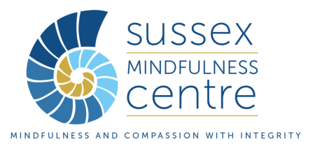


Online Mindfulness Retreat: Foundations of Mindfulness
with Kay Octigan and Robert Marx: 27th Sept (9am) - 1st Oct 2021 (1pm)

Who is this for?
The retreat is aimed at mindfulness teachers in training but would also be suitable for qualified mindfulness teachers and in particular for those wanting to bridge contemplative wisdom traditions and secular practice and teaching. The retreat will enable mindfulness teachers who wish to be included on the BAMBA Register of Mindfulness Teachers to fulfil the requirement to attend an annual mindfulness retreat.
Application form to be completed by applicant
Name:
Email address:
Correspondence address:
Contact telephone number/mobile number:
1. Have you attended a retreat(s) before? Please give details eg length, silence
2. Please let us know if you have any particular physical needs related to any past injuries, illness or limitations? Please let us know how we can support you with these.
3. Please let us know something here about your mental health.
Please include any relevant details about current or recent contact with a psychological or psychiatric service, medication or in-patient admissions. Please let us know how we can support you with this.
4. Please let us know about any disturbing or upsetting experiences you may have had in meditation
5. Have you had any disturbing, or unusually stressful incidents in your life recently?
Please also let us know if anything of this nature occurs before the retreat starts in September
6. Do you have any concerns about being in silence?
7. Do you have any questions or concerns about using Zoom or conducting an online retreat?
8. Please supply us with a contact name and mobile number for the person you would consent for us to contact in case of an emergency
9. Is there anything else you would like us to know or any way you’d particularly like us to support you?

Please return this form by email to: smc@sussexpartnership.nhs.uk
On offering you a place we will issue an invoice for payment in full.

From time to time, we would like to keep you informed of news and future events hosted by SMC but adding you to our
e-mailing list. Please tick the box if you give permission to add you to this list.
We will not pass your details on to anyone else outside of SMC. □

